Annual Report: UU Church of Nashua
Ben Atherton-Zeman
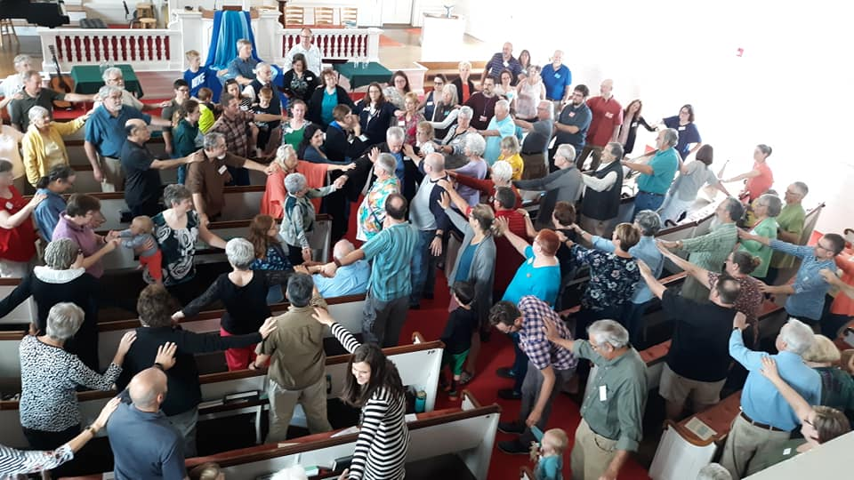
My first year of internship here has been wonderful! From my first day of work (staff retreat at Sherri’s house) to my first worship services and my installation (pictured right), I have felt supported, taught, nurtured and welcomed by the UUCN community. I have been guided by staff, by congregational leaders and by my hard working Intern Committee. My overall goal is to learn the skills needed to become a parish minister; more specifically, to achieve proficiency in the seven areas of proficiency required by the UUA Ministerial Fellowship Committee.
- Worship: I have given monthly sermons and participated in the Worship Team for many others. At the beginning of the year, I fumbled over the words used every Sunday, but improved as I gained more practice and confidence. I have received much positive feedback on my sermons, along with some constructive criticism, mostly centered on the need to keep the sermon focused. I have tried to incorporate this feedback into my sermon writing and delivery, and will continue to do so as worship moves online. In addition to sermons, I’ve facilitated alternate forms of worship such as the Contemplative Walk, Friday Fun with Ben, online Interfaith Prayers, the Huntington Group and the Solstice Labyrinth.

- Pastoral Care and Presence: With encouragement and support, I have begun to weave an almost-daily web of Sabbath practices, including contemplative walks through our church’s graveyard, prayer, singing bowl intoning and deep breathing. I have also taken leadership in the Pastoral Care Associates Team, and have done some pastoral counseling with several members of the congregation.

- Spiritual Development for Self and Others: I have participated in several Wonder Box activities during worship services, and co-led my first Worship service solely for young people. I’ve become one of four adult advisors to the Youth Group, and have supported this group through many meetings and outings. I cofacilitated a monthly Men and Masculinities group, which drew a loyal 10-15 male-identified people all year and continues to meet online during social distancing.

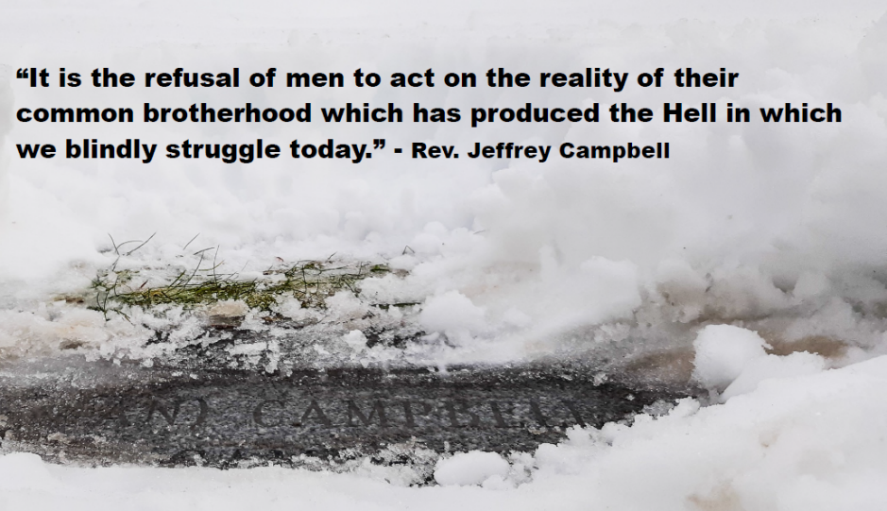
- Social Justice: Before COVID-19, I participated in a monthly interfaith walk for immigrant rights, in one case co-leading the opening prayers and singing. I coordinated the church’s participation in this year’s Hunger Walk, for which we raised over $3500 and had a large turnout in the pouring rain. Together with the Campbell Committee, I have posted monthly photos (pictured left) from the grave marker of Rev. Jeffrey Campbell and Marguerite Campbell Davis, two African-Americans who were sidelined by racism in our denomination. These photos have been accompanied by quotes from Rev. Campbell.

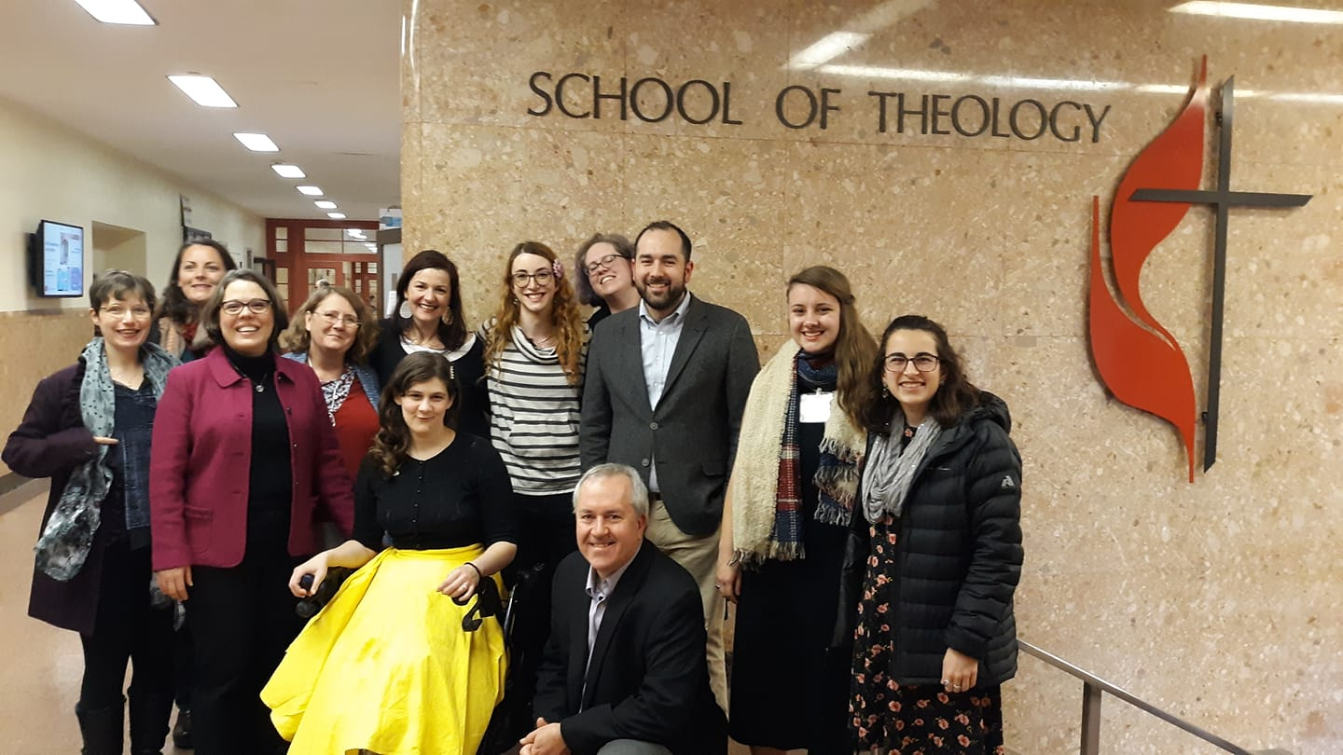
- Administration: I have been taught various computer programs and platforms: Google Docs, Breeze, Trello, WordPress, Instagram and Zoom. I participated in Board planning meetings and Board meetings, the Buildings and Grounds Team, the Music Team and weekly staff meetings. I have been mentored in church administration by Rev. Allison, Sadie, Sherri, Jed, our Treasurer and many others.

- Larger UU Faith: Most of my interaction with the greater UU denomination has been online, and it seems I will participate in my first General Assembly online as well. Fortunately, my years of membership in the UU community has given me some knowledge or our denomination. Additionally, the UU community at the Boston University School of Theology has given me opportunities such as sharing the pulpit with our UUA President (photo right). Finally, I’ve begun to participate in the Unitarian Universalist Minister’s Association Northern New England activities, as well as a Ministerial Formation Network group for divinity school students with disabilities.

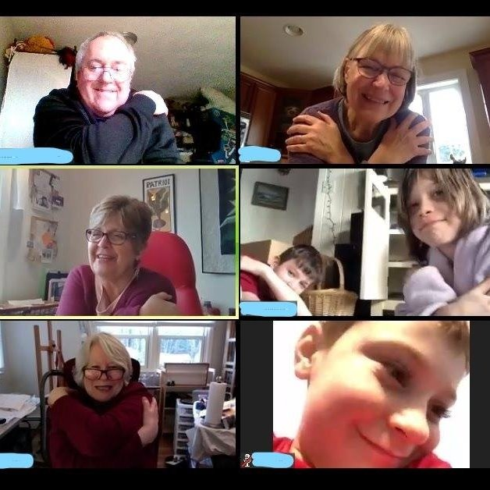
- Leads the Faith into the Future: I have increased the church’s Facebook presence, which has resulted in more visitors to the church. I make regular posts on Twitter and am learning to do so on Instagram. COVID-19 has prompted our denomination to adapt to online services, and I have learned much from Rev. Allison and the worship team about leading Zoom services. In our attempts to meet the congregation’s spiritual needs, we have increased our weekly worship offerings: this has allowed for new forms of worship like Friday Fun with Ben (mentioned above), a worship service that combines readings and contemplation with humor and play (photo left).

For my second year, I will build on the learning experiences listed above. More practice will give me the confidence in myself and my leadership abilities. By the time I go before the Ministerial Fellowship Committee, I will have the skills to attain fellowship as a UU Minister. In a year’s time, I hope to be called to serve a congregation as wonderful as this one, though it will be many years (if ever) that I gain the skills that Rev. Allison has. She will always be my role model for ministry, and this community will always be the first one I’ve fallen in love with. I thank you all for holding me with your gifts of welcome, teaching and fellowship.

